A Glimpse of In Vino Veritas I in Progress

For many, the lost wax process is a complete mystery. It is a lengthy process involving many, highly skilled hands which I refer to as my “ghost artists”. After the completion of the original sculpting and molding process, each casting requires approximately 12-16 weeks to complete. The process also requires a great deal of attention to detail, as many “mistakes” can require the entire process to start over at the very beginning, using a new wax model. Each piece must be poured and cleaned (dressed) in wax to a level where it matches the original sculpture - for each, individual casting. Unlike most sculptures cast in bronze, this includes a thorough cleaning of the interior of the vessel and each of the often hundreds of open cut-out areas for my vessel work.

The following images show just a few of the many stages each piece must go through to bring it into homes and businesses as a finished piece of art. The process is both fascinating and extremely labor intensive, while truly alchemical.

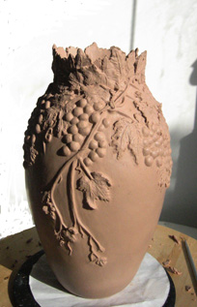
Completed sculpture (positive form) in oil based clay, ready to be molded.

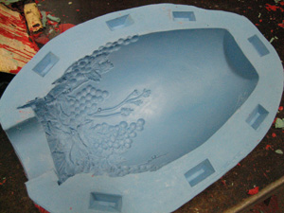
Open mold (half) ready to be closed and filled with melted wax.
This creates a negative form of the original sculpture.

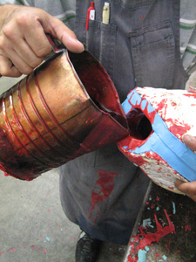
After carefully brushing first coats into each open section of the mold, melted wax is carefully poured into the closed mold

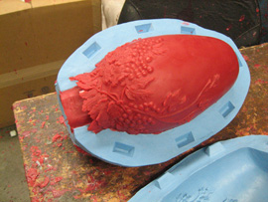
Cooled wax ready to be carefully removed from mold - this provides a new positive form of the sculpture for casting

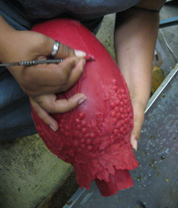
Cleaning (dressing) the cooled wax to match original sculpture - each cut- out area must be cut-out again in wax, seams removed, and interior and exterior must both be thoroughly cleaned

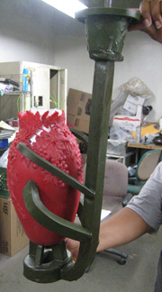

Completely dressed wax with gates (sprues) to allow for proper flow of molten bronze and release of the melted wax

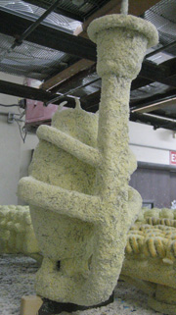
Invested vessel - many coats are applied via dipping to build up the silica type "shell" with drying required between the many dips.

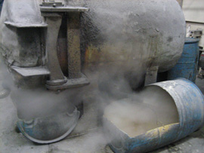
Vessel in the autoclave to remove the wax via pressure and steam - the result providing another negative form of the sculpture, now ready to receive the molten bronze

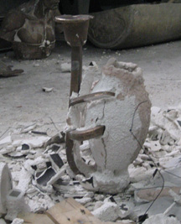
The sculpture, in shell and cooled - after pouring the molten bronze into the prepared shell. All the gates must be cut away now and the piece finely chased (cleaned in metal) to match the original sculpture. The bronze sculpture is hidden beneath the shell above.

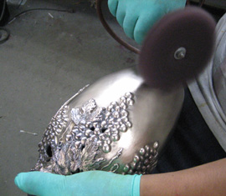
After the piece is completely chased it is sand-blasted, followed by preparing the surfaces, to various degrees, in preparation for the patina process to begin

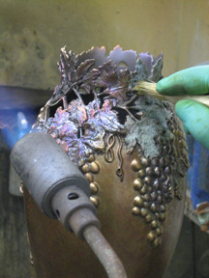
The lengthy patina process begins. The patina is applied with heat, upon various surface textures, in varying strengths and at various heat temperatures. Chemicals, pigments, and dyes are used in combination to create the desired finish. When completed, it is protected with an application of lacquer and/or wax.

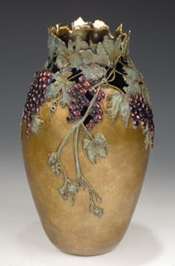
Completed sculpture: In Vino Veritas I

